We are here using 4 dim input vector

Notations :

Input : Xij => here i is input and j is dimension

Layers : layers are represent by layer1 , layer2 and layer3 (output layer)

Functions : Fij => here i is layer in which function is and j is index from top starting from 1.

Ex: F11 => function in layer 1 and it’s first neuron from top

F12 => function in layer1 and it’s second neuron from top

F21  => function in layer2 and it’s first from top

Outputs from neuron : Oij => it’s notation is same as neuron from its output.

Ex: O11 => it’s output from neuron f11 therefore it is O11 i.e output from neuron 1 of layer 1.

Weights : Wkij => here k represents into which layer weights goes into,

i from which number of neuron of input layer to j to which number of neuron it goes to in next layer.

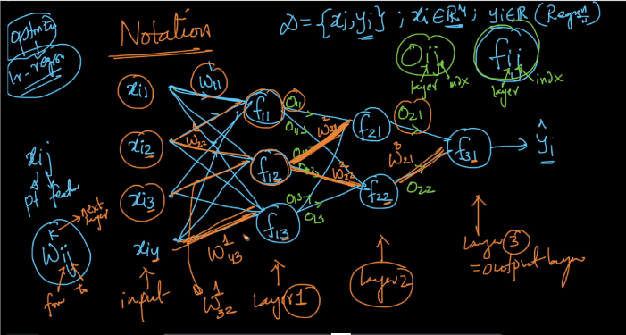

Fully connected Neural network :

Mean there must be all possibile connection i.e each input neurons connected to each next layer neuron

As shown all input 4 points are connected to next layer 3 neurons i.e 4\*3 = 12 connections

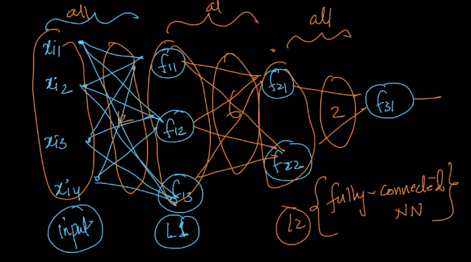

Weight Matrix: All the connections in neural network are represented by weight matrix which shown below

Below is the matrix of weights connecting input to layer 1. As there are 4 inputs and 3 neurons in layer 1 therefore weight matrix is of 4\*3 dim.

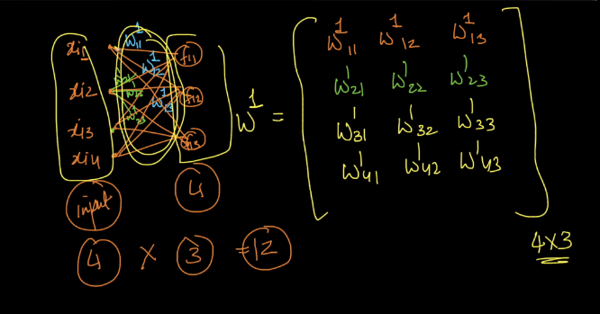

Therefore all connections in neural network are represented by data matrix

Connection b/w input and first layer represent by matrix w14\*3

b/w first and second layer by W23\*2

b/w second and output layer by W32\*3

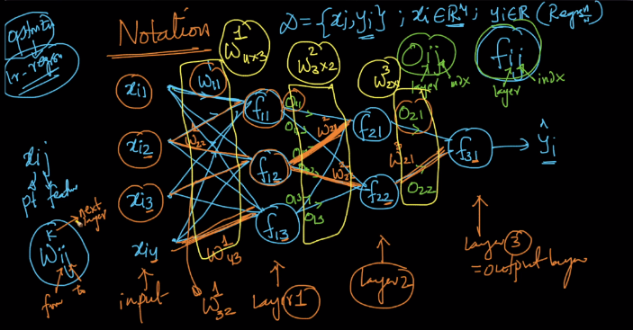

Comments :

